Charlie Nitschelm  
Trevor Blampied  
2/15/20  
China  
Professor Lan

Term Project Step #1 – Hong Kong

# The Physical Environment of Hong Kong

The city of Hong Kong sits in the southeast coast of China, shown below in Figure 1. “The territory is situated South of the tropic of Cancer which is equal to Hawaii in latitude (Environment of Hong Kong).” Its climate is subtropical for that reason, but for half of the year, it leans closer to a temperate climate.

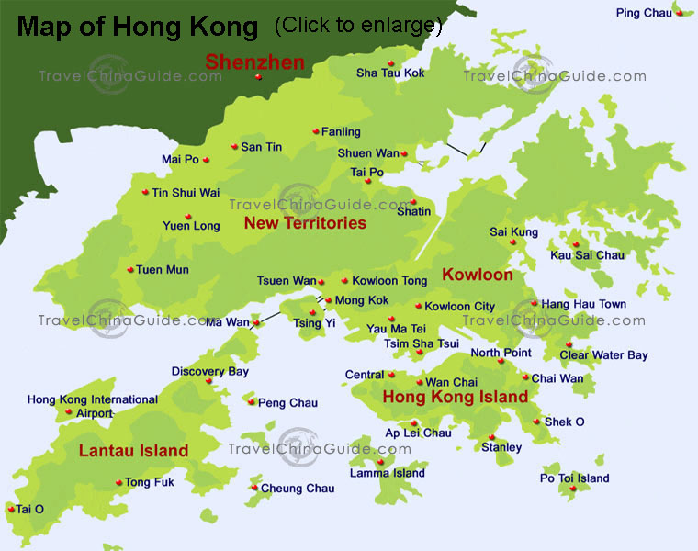

Figure 1 - Hong Kong located on the southeast point of China, https://www.travelchinaguide.com/map/hongkong/

During the summer months of May through September, it is quite monsoonal, as much of southeast Asia. It sees rains of more then 2,250 mm per annum, concentrated heavily during the summer months (Veeck 367). Hong Kong has a large and growing population. “The large and growing population has placed great stress on and degraded much of the original natural vegetation of Hong Kong (Veeck 368).” Due to this growth, the island, with its limited space, struggles to keep up with the amount of people wanting to live there. Its physical environment also poses problems for expansion. The majority of people live on Hong Kong Island, located south of Kowloon. An interesting feature of the island is that much of the island’s area is mountainous, limiting its ability to use all of its land. “Victoria Peak on Hong Kong Island is more than 300 m, a fact that allows for striking views and vistas of the surrounding waters and lands (Veeck 366).” Many people travel up the mountain by rail car or by hiking, a popular tourist attraction for visitors. Due to this physical constrain, much of the city is off of the mountain region of Hong Kong Island, on the north coast of the island. “Hong Kong is crowded. The land area is very limited, and the territory is simply small for such a large population, with a land area of 1,104 km2 and a population almost the size of Switzerland’s approximately eight million (Veeck 369).” This concentration of people enables creative solutions to allowing people to live there that want to, but it also creates a expensive housing industry, reaching some of the highest cost of living in the world. It has had implications to its natural environment with so much industrial development. During the earlier days of Hong Kong, the surrounding areas like the New Territories were used for farming and manufacturing, as Hong Kong Island did not have the land to support that. Today, much of Hong Kong does not produce its own food, and must be imported in from surrounding areas! As the city grows, its physical environment and climate have a huge affect and constrain on the city.

# The Politics of Hong Kong

Currently, Hong Kong has a huge political fight going on with the rights Beijing has over the people of Hong Kong. “Hong Kong has Special Administrative Region status which provides constitutional guarantees for implementing the policy of “one country, two systems” (Politics of Hong Kong).” What this means is that Hong Kong isn’t politically controlled by China, so they have a separation between China’s communist government and the more free-economy and free-speech Hong Kong has adopted since its British rule. “The idea of one country, two systems was proclaimed in which Hong Kong was to govern itself for fifty years, during which it was allowed to issue its own currency, provide its on police and administrative apparatus, continue its separate and independent judiciary, and operate a free and market-based economy (Veeck 373).” Since Hong Kong was transferred to China control in 1997 and the adoption of the ‘one country, two systems’ was agreed upon, Hong Kong has been able to maintain its way of life, and continues to grow stronger as it doesn’t align with the communist way. They still have more than 25 years of this deal being active (Veeck 364). The primary uprising of the Hong Kong people was the result of China trying to pass a bill that sets laws into Hong Kong that shouldn’t be controlled by the power of mainland China and Beijing. “The bill proposes a mechanism for transfers of fugitives not only for Taiwan, but also for Mainland China and Macau (Politics of Hong Kong).” This basically allows crimes in China apply to Hong Kong citizens, as they even have a different passport and currency then the rest of China. “Demonstrations and confrontation erupted between local people, who sought a greater voice in running local affairs through democratic procedures, and the Hong Kong authorities, who looked to Beijing for guidance (Veeck 373).” Many look down upon the way Hong Kong selects its chief executive, basically compared to power to the POTUS.

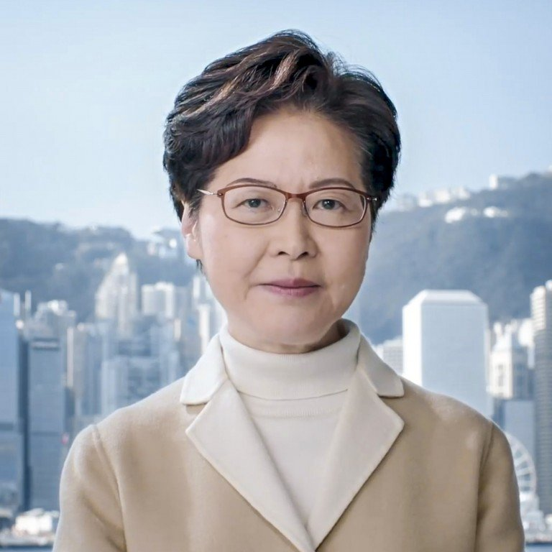

Figure 2 - Carrie Lam, the Chief Executive of Hong Kong

“China would vet and approve three candidates who could stand for the office (Veeck 375).” This forces Hong Kong to select a candidate the Beijing approves of, and most commonly, has their hands tied from the power lurking from Beijing and communist China. “More demonstrations followed in which local democratic parties demanded a greater voice in selecting candidates for office and a broader suffrage that would enable local people to vote for candidates of their choice (Veeck 375).” Although the situation has no clear end in sight, it seems the people of Hong Kong will not give up the fight to maintain their lifestyle and not integrate with China, as Beijing pushes harder and harder. We all know nothing good comes from taking freedom from people who have known it their entire lives. From history, we know people will die before they give up being free.

# The Economy of Hong Kong

“Hong Kong has had the highest degree of economic freedom in the world since the inception of the index in 1995 (Economy of Hong Kong).” Hong Kong is very different to how China interacts with other countries and their economies. Hong Kong is situated well to take advantage of trading opportunities throughout the world. In the past and today, Hong Kong quickly turned to a major hub of transport, for its easy access, free economy, and connection to the rest of the world for ships and planes as they rose to popularity in the 1930’s (Veeck 366). Hong Kong also supported a great low-cost and efficient labor supply that made it cheaper to do business with the city. These core reasons contributed Hong Kong to grow to an economy that is matched only to London and New York City today. “Hong Kong is one of the world’s most advanced economies in parallel with its very high per capita income of more than US$45,000, one of the wealthiest places on earth (Veeck 371).” It has its own currency, called the Hong Kong Dollar, that is matched with the USD. It doesn’t use the traditional China currency, which has allowed it to set itself apart from the communist methods of trade. Although Hong Kong has evolved over the years as it has kept up with the changes in technology and methods of doing business, “Today’s economy has three main supporting buttressed: shipping, finance, and tourism (Veeck 371).” But, as the riots of today’s political problems continue, tourism has fallen substantially. Even with that negative on how the political turmoil is affecting its economy, it has maintained an open and efficient market-oriented economy that supports the ethos of a focus on successful commerce with the rest of the world (Veeck 371).

# The Culture of Hong Kong

As Hong Kong has developed, it has had huge influences from both the west and east. Pre-industrial revolution and British control, it was mostly influenced by southeast Asia culture, but “It later became influenced by British culture due to British colonialism (Culture of Hong Kong).” Until 1997, it maintained under British control, but after the transfer of sovereignty to the People’s Republic of China, Hong Kong has now become a mesh of many different cultures, creating its own unique feel and people (Culture of Hong Kong). It has developed its own language different from the common language of Mandarin of China called Cantonese. From the influence of the West and the amount of trade and business that is done with the western world in Hong Kong, it also has English as primary language of the people of Hong Kong. “Hong Kongers are noted to have a habit of sprinkling their Cantonese with English words, resulting in a new speech pattern called Kongish (Culture of Hong Kong).” One of the most interesting traditions that any visitor of Hong Kong notes immediately is the large population of female domestic servant, usually immigrants from other Asian countries nearby. “Visitors to Hong Kong Island can witness large numbers of these women in Hong Kong’s Central District taking a day off on Saturdays and Sundays (Veeck 372).”

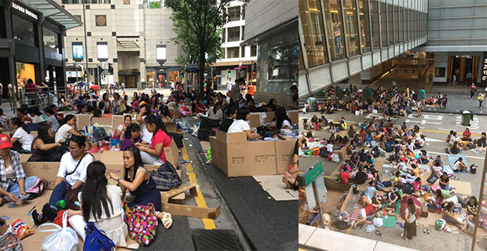

Figure 3 - Hong Kong servant break days that camp out throughout the Island of Hong Kong

This break day has a habit of completely filling areas of the city with people camped out, enjoying the day off and the nice weather commonly seen in Hong Kong Island. Hong Kongers and Chinese people often interact, as they have many people visiting from China every day. It is a common tourist visit area as it is a part of China but offers a very different feel then the communist mainland and more capitalist and free-speech environment. They do not have a great relationship with each other especially recently with the riots going on in protest of mainland China coming into their political system. “In some cases, these Chinese tourists have offended the local people by not observing strict rules on sanitation and other practices, leading to outbursts of criticism in the local press of the “rude behavior” of the mainlanders (Veeck 373).” Chinese tourists visiting many countries have bad reputations for being rude to the people who live there, so Hong Kong is not an exception. As Hong Kong continues to develop, it offers a beautiful mix of western and eastern culture and its traditions/feel.

# Works Cited

1. Veeck, Gregory. *China's Geography: Globalization and the Dynamics of Political, Economic, and Social Change*. Rowman & Littlefield, 2016.
2. “Environment of Hong Kong.” *Wikipedia*, Wikimedia Foundation, 19 Sept. 2019, en.wikipedia.org/wiki/Environment_of_Hong_Kong.
3. “Politics of Hong Kong.” *Wikipedia*, Wikimedia Foundation, 4 Jan. 2020, en.wikipedia.org/wiki/Politics_of_Hong_Kong.
4. “Economy of Hong Kong.” *Wikipedia*, Wikimedia Foundation, 9 Feb. 2020, en.wikipedia.org/wiki/Economy_of_Hong_Kong.
5. “Culture of Hong Kong.” *Wikipedia*, Wikimedia Foundation, 5 Jan. 2020, en.wikipedia.org/wiki/Culture_of_Hong_Kong.